**Abstract:**

An excavator is a piece of heavy equipment that is commonly used in construction work, mining work and work that requires lifting can be too heavy for humans. An excavator is a vehicle that is engineered and consists of things that can be used such as a backhoe and also has a cab that tends to be site is not inspected properly due to urgency of work by the owner or the contractor due to which improper handling of it leads to damage of the ground engaging tool i.e. bucket teeth. The teeth of the excavator are main contacting part of it which comes first in contact with the soil while doing excavation at various sites. This project is directed towards the modeling of Excavator bucket in a 3D CAD tool called solid works. The bucket and tooth are modeled and assembled.

**I. INTRODUCTION**

A bucket (also called a scoop to qualify shallower designs of tools) is a specialized container attached to a machine, as compared to a bucket adapted for manual use by a human. It is a bulk material handling component. The bucket has an inner volume as compared to other types of machine attachments like blades or shovels.

The bucket could be attached to the lifting hook of a crane, at the end of the arm of an excavating machine, to the wires of a dragline excavator, to the arms of a power shovel or a tractor equipped with a backhoe loader or to a loader, or to a dredge. The name "bucket" may have been coined from buckets used in water wheels, or used in water turbines or in similar-looking devices. Buckets in mechanical engineering can have a distinct quality from the traditional bucket (pail) whose purpose is to contain things.

Larger versions of this type of bucket equip bucket trucks to contain human beings, buckets in water-hauling systems in mines or, for instance, in helicopter buckets to hold water to combat fires.

Two other types of mechanical buckets can be distinguished according to the final destination of the device they equip: energy-consumer systems like excavators or energy-capturer systems like water bucket wheels or turbines. Buckets exist in a variety of sizes or shapes. They can be quite large like those equipping Hulett cranes, used to discharge ore out of cargo ships in harbors or very small such as those used by deep-sea exploration vehicles. The shape of the bucket can vary from the truncated conical shape of an actual bucket to more scoop-like or spoon-like shapes akin to water turbines. The cross section can be round or square.

**II. LITERATURE SURVEY**

There are four major area of work say kinematics, dynamics,soil-tool interaction and FEA and optimization on which the literature review carried out for development of kinematic model, dynamic model, utilization of soil-tool interaction model for resistive force calculations, FEA for strength based design and to develop optimized design of backhoe excavator attachment.

**A.Literature Review on Kinematics of backhoe excavator attachment**

An excavator is a typical hydraulic heavy-duty human-operated machine used in general versatile construction operations, such as digging, ground levelling, carrying loads, dumping loads and straight traction. these operations require coordinated movement of boom, arm and bucket in order to control the bucket tip position to follow a desired trajectory. The basic problem in the study of mechanical link mechanism is of computing the position and orientation **KATLA PRASANTH,**

**1.1 Typesof Bucket**

**A. Digging Bucket:** The most common excavator bucket is the digging bucket. It is the standard bucket that comes with every excavator. These all purpose buckets are used to plough through hard soil, rocks or even frost covered soil. They come in various sizes and shapes with short blunt teeth, to break through hard soil. These teeth may be longer and sharper, depending on the hardness of the soil.

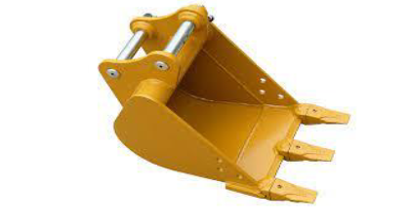

**Fig -1**: Digging Bucket

**B. Rock Bucket:** This excavator bucket is meant to work with hard rocks. They are similar in design to digging buckets but have reinforced structural parts for strength. They have longer, sharper teeth, narrow V-shaped cutting edge, and can push with more power. They can break through hard rock while maintaining their structural integrity.

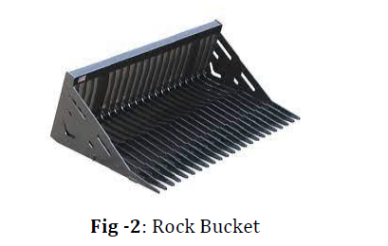

**C. V-Bucket:** The V bucket is a special excavator bucket. It has a V shaped structure that helps it penetrate easily through the soil. The angled sides make it easier to dig. This saves costs on power while digging. Work that involves laying pipes is ideally suited to this type of excavator bucket

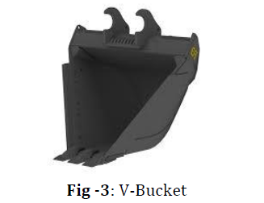

**D. Skeleton Bucket**: A skeleton bucket is a modified digging bucket. It accomplishes an additional task while digging. The bucket is made up of bars that have gaps. Small particles fall through these gaps during excavation. This utility is helpful in segregating coarser soil with finer particles.

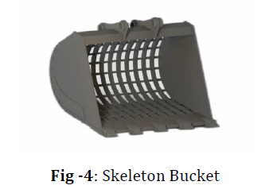

1.2 Problem Statement

The excavator mechanism must even work under unpredictable operating conditions. Poor strength properties of the excavator parts like boom, arm and bucket limit the life of the excavator. Therefore, excavator parts should be robust enough to cope with caustic operating conditions of the excavator. The skilled operator is unaware of condition of road, soil parameter and sand force transmitted from soil during excavation process. These forces should consider for better design of tools, other parts of excavators, and for planning trajectory motion. In today’s world, weight is one of the major concerns while planning and designing any machine parts. So for reducing the overall price further as for smoothing the performance of machine, modification is required.

II. CALCULATION OF DIGGING FORCES OF BUCKET AND ARM

1. *Forces*
2. 
3. *B. Bucket Digging Force:*
4. Bucket digging force is defined as maximum digging force
5. due to bucket cylinder in tangential direction at bucket
6. tooth.
7. *1) Pressure of Bucket Cylinder:*
8. It is the pressure of bucket cylinder according to the
9. operation pressure of hydraulic oil, it is depend on the next
10. formulation:
11. F2= (/4)* Db
12. 2 * Pb
13. Bucket digging force:
14. Fb = (F2∗ A∗ C)/ (R1∗ B)
15. Values Found by Actual Practical Observation:
16. A= 620mm
17. B= 820mm
18. C= 490mm
19. R1= 1325mm
20. Db= 125mm
21. Pb= 0.071Mpa
22. *2) Calculations:*
23. F2= (/4)* Db
24. 2 * Pb =(.785)*15625*0.071 = 870.85KN
25. Fb = (F2∗ A∗ C)/ (R1∗ B) =(870.85*620*490)/(1325*820)
26. =243.501KN
27. *3) Arm Digging Force:*
28. Arm digging force is defined as maximum digging force due
29. to arm cylinder in tangential direction at bucket tooth in
30. position where bucket tooth force due to bucket cylinder is
31. maximized.
32. *4) Pressure of arm cylinder:*
33. It is the pressure of arm cylinder according to the working
34. pressure of hydraulic oil, and it is depend on the next
35. formulation:
36. *C. Arm digging force:*
37. *1) Force Explanation:*



Values Found by Actual Practical Observation:

R2= 3750mm

R3= 640mm

Da= 135mm, Pa= 0.061Mpa

F1= (/4) Da

2 * Pa

F1= (0.785) *18225*0.061

F1=872.70KN

Fa = F1∗ R3 R2 = 701.38∗ 650 3700 = 123.21kN

Arm digging force = 123.21kN

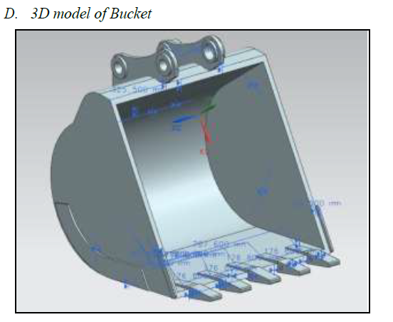

**OBJECTIVES**

1) To Reduction in material which will reduces weight of bucket by modification and ultimately reduces basic and operating cost.

2) Stress Analysis to find the possible deformation and stress concentrated areas.

3) To do the Structural analysis on excavator bucket with different materials at various loads.

4) To find behavior of the modified excavator bucket by comparing with exsiting bucket model.

**2. METHODOLOGY**

In our project work we have setup design procedure based on exsiting design data and past literature research papers. We have gone through the mathematical calculations and obtained the geometrical parameters for the 3D model of an excavator bucket.

1. First we will calculate the Bucket digging force form the following equation,

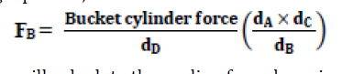

1. 2. Next we will calculate the curling force by using following equation,

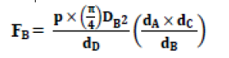

3. Then we will calculate the Bucket capacity by using following two eqations

VB = Vs + Ve

Where,

VB = Bucket capacity,

Vs = Struck capacity and

Ve = Excess capacity,

4. Next we will calculate forces which are acting on the bucket,

5. Design Parameters

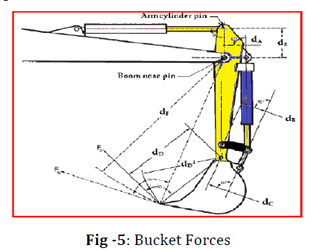

Where,

dA = Distance between Boom and arm fixed point = 700 mm

dB = Distance between arm and bucket cylinder fixed point = 470 mm

dC = Distance between arm end and cylinder end fixed point = 290 mm

dD = Distance between bucket end to the tip of teeth of bucket = 1150 mm

dE = Distance between boom cylinder end and arm cylinder end = 450 mm

6. Next we have considered the existing bucket forces acting on bucket.

8. And then we design excavator bucket according to step 1 to 7

9. 3D Modelling of the excavator bucket is carried out using modelling software CATIA. And also we made some changes in new model by comparing with existing bucket model to increase the volumetric efficiency of bucket.

10 Bucket analysis is done with the help of Ansys software for comparing the result of stresses and total deformation.

11. Final result is compared with existing model of bucket.

**3. Design & Force Calculations**

**3.1 Design Detail of modified bucket**

|  |  |  |  |  |  |
| --- | --- | --- | --- | --- | --- |
| **Table-1:** Design Detail of modified bucket **Plate Thickness** | **No. of Teeth** | **Height of Bucket** | **Width of bucket** | **Length of Bucket** | **Vol. Capacity** |
| 20mm | 4 | 771.2mm | 1000mm | 1022mm | 0.6279m3 |

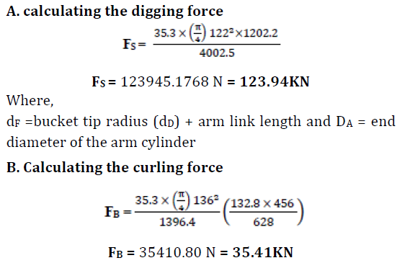

When the assembly of proposed model is placed in the position as shown in Fig. 5.4 it holds the values of the parameters as: dA = 132.8 mm, dB = 628 mm, dC = 456 mm, dD = 1396.4 mm, dE = 1202.6 mm, and dF = 4002.5 mm. The working pressure p = 35.3 MPa, DA=122, DB=136.

The bucket curl or breakout force FB = 35.41KN and arm crowd force or digging force FS = 123.94 KN.

**3.2 Bucket capacity calculations**

**1. Bucket capacity** is a measure of the maximum volume of the material that can be accommodated inside the bucket of the backhoe excavator. Bucket capacity can be either measured in struck capacity or heaped capacity as described



**Fig -6**: (a) Bucket struck (b) heaped capacities

**2. Struck capacity**

Struck capacity is defined as: The volume capacity of the bucket after it has been struck at the strike plane. The strike plane passes through the top back edge of the bucket and the cutting edge as shown in Fig.6 (b). This struck capacity can directly be measured from the 3D model of the backhoe bucket excavator.

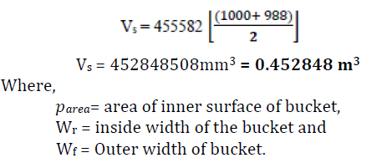

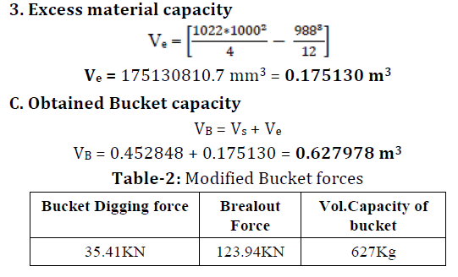

**4. Modeling & Analysis of Bucket**

**4.1 Modeling of Excavator Bucket**

3D model of the excavator bucket was developed in Catia V5 from the design calculations done. The model was then converted into a parasolid to import into ANSYS. A Finite Element model was developed with solid elements. The elements that are used for idealizing the bucket were described below

**Table 1. The Shape of Bucket Teeth**

**Bucket teeth Description Figure**

Standard It is used in loading, hauling, excavating works. Its wear rate is high.



Rock Chisel

It is used for general excavation work with more abrasive materials. It has

wear and tear age of 3-5 times bigger than other shapes of teeth.



Rock Penetration It is on work in rocky media that requires high penetration.



**Computer Aided Design (CAD)**

**Contents**

**1 Computer-Aided Design (CAD) ............................................................................................... 3**

1.1 Software and Technology .................................................................................................................................. 3

1.1.1 Commercially Available CAD Systems: ................................................................................ 4

1.1.2 Freeware and Open Source ................................................................................................. 5

1.2 Solid (Geometry) Modeling ............................................................................................................................... 5

1.2.1 Principal Characteristics of a Solid Modeling Software ....................................................... 5

1.2.2 Feature-Based Modeling ..................................................................................................... 5

1.2.3 Constraint-Based Modeling ................................................................................................. 5

1.2.4 Parametric Modeling ........................................................................................................... 5

1.2.4.1 Parameter Space ............................................................................................................ 6

1.2.5 History-Based Modeling ...................................................................................................... 6

1.2.6 Associative Modeling ........................................................................................................... 6

1.3 Constructive Solid Geometry (CSG) Representation of Solids ............................................................. 6

1.3.1 Basic Primitives .................................................................................................................... 6

1.3.2 Regularized Boolean Operators ........................................................................................... 7

1.4 The CSG Tree ........................................................................................................................................................... 7

1.5 Geometry Related Issues For Mesh Generation ........................................................................................ 7

1.5.1 Understanding the Analysis Requirements ......................................................................... 8

1.5.2 Dis-Featuring....................................................................................................................... 9

1.5.3 “Dirty” Geometry ............................................................................................................... 10

1.5.4 Non-Manifold Geometry ................................................................................................... 10

1.5.5 References ......................................................................................................................... 10

**List of Tables**

No table of figures entries found.

**List of Figures**

Figure 2.1.1 Anatomy of commercial CAD Systems .............................................................................................. 3

Figure 2.1.2 Fighter Airplane F-16 calculation ....................................................................................................... 4

Figure 2.3.1 Example of a CSG Tree ............................................................................................................................. 7

Figure 2.5.1 Geometry Import and Preparation ..................................................................................................... 8

Figure 2.5.2 Different Analysis Require Different Geometric Representations ........................................ 8

Figure 2.5.3 Small Feature (Left) vs Removed (Right) ........................................................................................ 9

**1 Computer-Aided Design (CAD)**

***Computer-Aided Design (CAD)*** is the use of computer systems (or workstations) to aid in the creation, modification, analysis, or optimization of a design1. CAD software is used to increase the productivity of the designer, improve the quality of design, improve communications through documentation, and to create a database for manufacturing. CAD output is often in the form of electronic files for print, machining, or other manufacturing operations. The term CADD (for ***Computer Aided Design and Drafting***) is also used2. CAD may be used to design curves and figures in two-dimensional (2D) space; or curves, surfaces, and solids in three-dimensional (3D) space. CAD is an important industrial art extensively used in many applications, including automotive, shipbuilding, and aerospace industries, industrial and architectural design, prosthetics, and many more. CAD is also widely used to produce computer animation for special effects in movies, advertising and technical manuals, often called DCC digital content creation. The modern ubiquity and power of computers means that even perfume bottles and shampoo dispensers are designed using techniques unheard of by engineers of the 1960s. Because of its enormous economic importance, CAD has been a major driving force for research in computational geometry, computer graphics (both hardware and software), and discrete differential geometry3.

**1.1 Software and Technology**

Originally software for Computer-Aided Design systems was developed with computer languages such as Fortran, ALGOL but with the advancement of object-oriented programming methods this has radically changed. Typical modern parametric feature based modeler and freeform surface systems are built around a number of key C modules with their own APIs. A CAD system can be seen as built up from the interaction of a graphical user interface (GUI) with NURBS geometry or boundary representation (B-rep) data via a geometric modeling kernel. A geometry constraint engine may also be employed to manage the associative relationships between geometry, such as wireframe geometry in a sketch or components in an assembly. Unexpected capabilities of these associative relationships have led to a new form of prototyping called digital prototyping. In contrast to physical prototypes, which entail manufacturing time in the design. That said, CAD models can be generated by a computer after the physical prototype has been scanned using an industrial CT scanning machine. Depending on the nature of the business, digital or physical prototypes can be initially chosen according to specific needs.

Figure 1.1.1 Anatomy of commercial CAD Systems

**CAD Management**

**Grid Generation**

**CFD**

Today, CAD systems exist for all the major platforms (Windows, Linux, UNIX and Mac OS X); some packages support multiple platforms. CAD software enables engineers and architects to design, inspect and manage engineering projects within an integrated graphical user interface (GUI) on a personal computer system. Most applications support solid modeling with boundary representation (B-Rep) and NURBS geometry, and enable the same to be published in a variety of formats. A

geometric *SolidWorks, Autodesk* modeling kernel is a software component that provides solid modeling and surface modeling features to CAD management applications. Based on market statistics, commercial software from *Autodesk*, *Dassault Systems, Siemens PLM Software and PTC* dominate the CAD industry. Presently, most of commercially available CAD systems, such as or *Siemens NX*, calming to be able to do faster design loops, are also including a CFD analysis tool (some with limited capabilities), and Grid Generation kernel, in their product. (see **Figure 1.1.1**).

Figure 1.1.2 Fighter Airplane F-16 calculation

For example, using SolidWorks, to solve the symmetric algebraic problem for pressure-correction, an original double preconditioned iterative procedure is used4. It is based on a specially-developed multigrid method from [Hackbusch (1985)]. This is an external flow around a F-16 fighter (Mach Number equals 0.6 and 0.85). The geometry is a native CAD model of the airplane with external tanks and armaments. Flow into the intake and exhaust from the engine’s nozzle are both taking into account. Calculations were performed with relatively coarse grid of approximately 200,000 cells. (see **Figure 1.1.2**). Calculation results are compared with the test data from [Nguyen, Luat T. et al.].

1.1.1 Commercially Available CAD Systems:

The following is a list of major CAD applications.

1. AutoCAD
2. Creo
3. Catia
4. SolidWorks
5. NX (Unigraphics )

**1.2 Solid (Geometry) Modeling**

A solid model is a computer model of a 3D solid. It is a virtual representation of the shape of a solid5. Solid models can be simple parts, or complex assemblies of multiple parts. We aim here at explaining how such solids can be described on a computer. We will principally focus on the ability of such solid models to serve as input to numerical simulations.

1.2.1 Principal Characteristics of a Solid Modeling Software

A solid modeling software may have some specific characteristics that enables to enhance both its efficiency and the productivity of the solid modeling process:

1.2.2 Feature-Based Modeling

Features are defined to be parametric shapes associated with attributes such as intrinsic geometric parameters (length, width, depth etc.), position and orientation, geometric tolerances, material properties, and references to other features. Feature-based modelers allow operations such as creating holes, fillets, chamfers, bosses, and pockets to be associated with specific edges and faces. When the edges or faces move because of a regeneration, the feature operation moves along with it, keeping the original relationships.

1.2.3 Constraint-Based Modeling

There are two types of constraints. Dimensional constraints are used to specify distances between items. Geometric constraints define positional relationships between entities in the model in terms of the geometry. Examples of geometric constraints include tangency, parallelism, symmetry, concentricity. Constraint-based modeling allows the engineer or designer to incorporate intelligence into the design. The initial sketch of a two-dimensional profile in constraint-based solid modeling does not need to be created with a great deal of accuracy. It just needs to represent the basic geometry of the cross section. The exact size and shape of the profile is defined through assigning enough parameters to fully constrain it.

1.2.4 Parametric Modeling

Parametric modeling means that parameters of the model may be modified to change the geometry of the model. A dimension is a simple example of a parameter. When a dimension is changed, the geometry of the part is updated. Thus, the parameter drives the geometry. An additional feature of parametric modeling is that parameters can reference other parameters through relations or equations. The power of this approach is that when one dimension is modified, all linked dimensions are updated according to specified mathematical relations, instead of having to update all related dimensions individually. Simply put, ***parametric modelling involves the building or design of 3D geometrical models piece by piece.*** The process usually starts with a 2D sketch followed by the integration of constraints, dimensions, and entities to form a defined 3D model. These constraints, dimensions, and other entities are known as parameters.

Conversely, ***non-parametric modelling involves a direct approach to building 3D models without having to work with provided parameters***. Therefore, you will not be required to start with a 2D draft and produce a 3D model by adding different entities. This means you directly model your ideas

1.2.4.1 Parameter Space

The parameter space is the space of possible parameter values that define a particular mathematical model, often a subset of finite-dimensional Euclidean space. Often the parameters are inputs of a function, in which case the technical term for the parameter space is domain of a function. The ranges of values of the parameters may form the axes of a plot, and particular outcomes of the model may be plotted against these axes to illustrate how different regions of the parameter space produce different types of behavior in the model6.

1.2.5 History-Based Modeling

The last aspect of solid modeling is that the order in which parts are created is critical. This is known as history-based modeling. For example, a hole cannot be created before a solid volume of material in which the hole occurs has been modeled. If the solid volume is deleted, then the hole is deleted with it. This is known as a parent-child relation. The child (hole) cannot exist without the parent (solid volume) existing first. Parent-child relations are critical to maintaining design intent in a part. Most solid modeling software recognizes that if you delete a feature with a hole in it, you do not want the hole to remain floating around without being attached to the feature. Consequently, careful thought and planning of the base feature and initial additional features can have a significant effect on the ease of adding subsequent features and making modifications.

1.2.6 Associative Modeling

The associative character of solid modeling software causes modifications in one object to “ripple though" all associated objects. For instance, suppose that you change the diameter of a hole on the "engineering drawing that was created based on your original solid model. The diameter of the hole will be automatically changed in the solid model of the part, too. In addition, the diameter of the hole will be updated on any assembly that includes that part. Similarly, changing the dimension in the part model will automatically result in updated values of that dimension in the drawing or assembly incorporating the part. This aspect of solid model software makes the modification of parts much easier and less prone to error. As a result of being feature based, constraint based, parametric, history based, and associative, modern solid modeling software captures “design intent", not just the design.

This comes about because the solid modeling software incorporates engineering knowledge into the solid model with features, constraints, and relationships that preserve the intended geometric relationships in the model.

**1.3 Constructive Solid Geometry (CSG) Representation of Solids**

We discuss here briefly the *Constructive Solid Geometry (CSG)* representation of solids. CSG allow to construct complex solid through primitives, Boolean operators and rigid motions.

1.3.1 Basic Primitives

The standard CSG basic primitives are the sphere, the torus, the parallelepiped (block), the cylinder and the cone. All those primitives defined bounded closed orientable domains. All basic primitives are defined in the world system of coordinates. Rigid motions (rotations, translations) and scaling can be applied to re-position the primitives.

1.3.2 Regularized Boolean Operators

Each primitive divides the 3D space into two parts: the one that is inside the primitive and the one that is outside. The closure of a primitive is the surface that separates its interior with its exterior. It is easy to think a primitive as a set where standard Boolean operations like union, intersection and difference can be defined. Basic primitives can be combined using Boolean operations. Three Boolean operators are defined. Consider two primitives A and B.

Figure 1.3.1 Example of a CSG Tree

➢ The Union A ⋃ B operation returns of all the points x ∈ R3 that are either inside A or inside B.

➢ The Intersection A ⋂ B operation returns of all the points x ∈ R3 that are both inside A and inside B.

➢ The Difference A n B operation returns of all the points x ∈ R3 that are inside A and outside B.

Regularized Boolean operators differ from the set-theoretic ones in that dangling lower dimensional structures are eliminated, all remaining faces, edges and vertices belonging to the closure of the resulting volume.

**1.4 The CSG Tree**

A CSG object can be easily represented in a tree structure where the leaves of the tree are simple primitives, nodes of the tree are solids, edges of the tree are Boolean operations and where the root of the tree is a solid that is the final CSG object. **Figure 1.3.1** shows an example of a simple CSG tree. Most of the current commercial solid modelers enable to use CSG trees. Designing robust algorithms for computing both the geometry and the topology of surface intersections is a complex problem. A few number of software enable to perform CSG computations efficiently and, to our best knowledge, only one is open source. In *Gmsh*, we have interfaced Open cascade primitives and operators to build the solid of **Figure 1.3.1**.

**1.5 Geometry Related Issues For Mesh Generation**

One of the major issues of mesh generation is access to CAD geometry in an accurate and efficient manner, as addresses by [Beall et al.]7. Here, we will provide an overview the process of accessing CAD geometry for mesh generation and will review several of the issues associated with accessing

CAD geometry for mesh generation. The techniques for CAD geometry access to be reviewed include: ***Translation & Healing, Discrete Representations, Direct Geometry Access,*** and ***Unified Topology Accessing Geometry Directly.*** The intent of this paper is to provide an overview to the alternative approaches and how they address the specific issues related to accessing CAD geometry for mesh generation. It is not the intent of this paper to provide detailed algorithms related to accessing or repairing CAD data. There are several issues associated with effective and efficient access of CAD geometry for mesh generation. This section will provide a quick overview of several of the major issues and the ramifications that this issues have on mesh generation. In summary, the geometry import can be devised in three steps, following [Yasuda]8 for HL- CRM mesh development, where ***CFLOW*** compromises a grid generator and flow solver. (See **Figure 1.5.1**).

Figure 1.5.1 Geometry Import and Preparation

1.5.1 Understanding the Analysis Requirements

The first major issue with CAD geometry access for mesh generation is the need to understand the analysis requirements. The appropriate mesh and geometry to be used for meshing is a function of the analysis to be performed and the desired accuracy. There does not exist an optimal mesh independent of the analysis to be performed. ***A-prior*** element shape quality test have often been used as a misleading indicator of a good mesh independent of the analysis to be performed or the

Figure 1.5.2 Different Analysis Require Different Geometric Representations

accuracy desired. The appropriate mesh is one that produces the desired accuracy for the problem to be solved. In practice this is only achievable through adaptively. Different types of analyses require different instances of the geometry to capture the physics. For example, we can perform a dynamic structural response analysis and a Computational Fluid Dynamics (CFD) analysis on the same part. The dynamic structural response analysis requires the solid geometry of the part while the CFD analysis requires the geometry of the cavities through which the fluid will flow. This simple illustration of different use of geometry representations is illustrated in **Figure 1.5.2**. Dynamic structural response analysis requires solid geometry of the part. While CFD analysis requires geometry of the flow cavities. Different types of analysis also require different resolutions of mesh to achieve the desired accuracy on a particular design.

1.5.2 Dis-Featuring

Disfeaturing is one of the most complex issues associated with CAD geometry access for mesh generation. Indeed one of the major issues that the CAD and CAE software industries have encountered is developing a consistent definition of a feature. For the purposes of this paper we will classify features into two main groups. The first group of features will be called “intended features”. ***Intended features*** are features that were explicitly defined as features in the model that drive the resulting geometry. In this case a feature-based modeling system was used to create a model which contains ***intended features.*** *Intended features* can only be created by feature-based modeling systems and can be suppressed by the original modeling system. The second group of features will be called “***artifact features***”. Artifact features are features that are created indirectly by the modeling process. One example of artifact features is the creation of engineering features such as holes by a modeling system that is not feature-based. The second example of ***artifact features*** is the creation of recognizable patterns of geometry / topology data that create a valid design model but also create difficulties associated with mesh generation. Artifact features can be created from any modeling system and cannot be suppressed in the original modeling system. **Figure 1.5.3** illustrates small features removed from geometry.

Figure 1.5.3 Small Feature (Left) vs Removed (Right)

Part of the complexity associated with CAD geometry access for mesh generation is due to the fact that historically analyses are performed too late in the design process and the design model contains more details than are appropriate for analysis. Moving the analysis earlier in the design process will help to reduce, but will not remove, the need for defeating. Since multiple analysis types may be

required for any design state there remains a need for defeating to various levels to support the range of analysis to be performed.

1.5.3 “Dirty” Geometry

***Dirty*** geometry has been one of the most nagging issues related to geometry access. ***Dirty*** geometry consists of gaps, overlaps and other incompatibilities in the model preventing the model from being valid. These incompatibilities do not exist in the native CAD system and are introduced from translating the native CAD geometry to another format. Differences in representations, methods and tolerances between modeling engines create *dirty* geometry. Translators must then heal or repair the geometry to represent it as a valid model in the non-native system9-11. Note that without knowledge of the modeling system tolerances and methods, there is no *a* ***priori*** means to ensure a healing process will successfully recover the correct model representation. To alleviate, recently, *ANSYS 2019 R2©* rolled out a new fault-tolerant workflow that simplifies CFD meshing. However, some of the most important and complex CFD simulations, still contain dirty, non-watertight geometries. For instance, the geometry used in simulations of automotive front-end airflows, external aerodynamics and complex external/internal flows can’t be meshed using the task-based workflow. As a result, these geometries require extensive cleanup before simulation.

1.5.4 Non-Manifold Geometry

A non-manifold geometry is a 3D shape that cannot be unfolded into a 2D surface with all its ***normal*** pointing the same direction. Examples include ***Multiply connected geometry***, ***Several surfaces connected to a single vertex, Internal faces, Disconnected vertices and edges*** etc. The non-manifold geometry is problematic in mesh generation sense and should be avoided or resolved prior to that.

1.5.5 References

1 Duggal, Vijay (2000). Cadd Primer: *A General Guide to Computer Aided Design and Drafting-CADD*, Mailmax Pub. ISBN 978-0962916595.

2 Wikipedia.

3 See Previous

4 Solidworks, “*Numerical Basis of CAD-Embedded CFD*”, White Paper.

5 Christophe Geuzaine, Emilie Marchandise , and Jean-Francois Remacle, “*An introduction to Geometrical Modelling and Mesh Generation*”, The Gmsh Companion.

6 Wikipedia,

7 Mark W. Beall1, Joe Walsh2, Mark S. Shephard, “*Accessing CAD Geometry For Mesh Generation*”.

8 Hidemasa Yasuda, Taku Nagata, Atsushi Tajima, Akio Ochi, “KHI Contribution to GMGW-1”, Kawasaki, 1st Geometry and Mesh Generation Workshop Denver, CO June 3-4, 2017.

9 Butlin, G., Stops C., “*CAD Data Repair*”, Proc. 5th Int. Meshing Roundtable, pp. 7-12, 1996.

10 Mezentsev, A.A. and Woehler, T., “Methods and algorithms of automated CAD repair for incremental surface meshing”, *Proc. 8th Int. Meshing Roundtable,* Sandia report SAND 99-2288, 1999.

11 Ribo, R., Bugeda, G. and Onate, E., “Some algorithms to correct a geometry in order to create a finite element mesh”, *Computers and Structures*, 80:1399-1408, 2002. View publication stats

**Introduction to 3D Printer**

3D Printing or additive manufacturing is a process of making a three-dimensional solid object of virtually any shape from a digital model. Successive layers of material are laid down to construct a customized object. Each layer can be seen as a thinly sliced horizontal cross-section of the eventual object. The available materials also vary by process. Plastics are the most common, but metals, optically clear and rubber like objects can also be 3D printed.

3D Printing enables the production of complex shapes using less material than traditional subtractive manufacturing methods which involve cutting/ machining out the object from a larger block.

The 3D Printer makes a three-dimensional solid object from a digital model. It consists of 3D printing apparatus attached to a multi-axis robotic arm. The arm consists of a nozzle that deposits metal powder or wire on a surface; and an energy source (laser, electron beam or plasma arc) that melts it, forming a solid object.

Printer Resolution describes layer thickness and X-Y resolution in dots per inch (dpi) or micrometres (μm). Typical layer thickness is around 100 μm (250 dpi). Some machines can print layers as thin as 16 μm (1600 dpi). The particles are around 50 to 100 μm (510 to 250 dpi) in diameter. The X-Y solution is comparable to that of laser printers. Specifying higher resolution results in larger files.

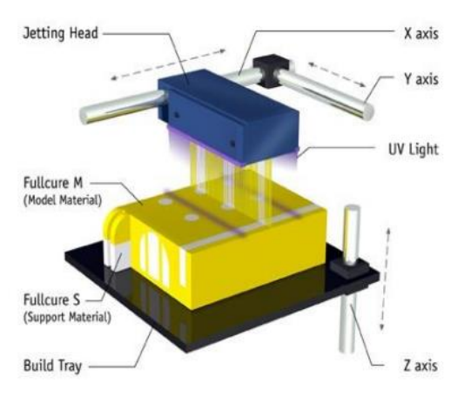

How 3D Printer works? The first step of 3D printing is 3D scanning. 3D scanning is a process of collecting data on the shape and appearance of a real object, creating a digital model based on it. 3D printable models may be created with a computer-aided design (CAD) package, a 3D scanner or a plain digital camera and photogrammetry software. 3D printed model created with CAD result in reduced errors and can be corrected, allowing verification in the design of the object before it is printed.

Most CAD applications produce errors in output STL files of holes, face normals, self-intersections, noise shells etc. Generally, 3D scanning often introduces more errors due to point-by-point acquisition. The manual modeling process of preparing geometric data for 3D computer graphics is similar to plastic arts such as sculpting.

CAD models can be saved in the stereolithography file format (STL), that stores data based on triangulations of the surface of the CAD models. STL is not tailored for additive manufacturing because it generates large file sizes of topology optimized parts and lattice structures; due to the large number of surfaces involved. A newer CAD file format, Additive Manufacturing File Format (AMF) was introduced to store information using curved triangulations. The STL file is processed by a software called slicer, which converts the model into a series of thin layers and produces a G-code file containing instructions tailored to a specific type of 3D Printer. The G-code file can then be printed with 3D printing client software.

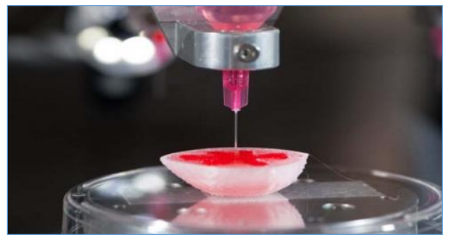

3D Printing Process The ISO/ ASTM 52900 standard categorized all different types of 3D printing under one of these seven groups:

1. Metal Extrusion (FDM): A spool of filament is loaded into the printer and ten fed to the extrusion head, which is equipped with a heated nozzle. Once the nozzle reaches the desired temperature, a motor drives the filament through to melt it.
2. The printer moves the extrusion head, laying down melted material at precise locations, where it cools and solidifies. When a layer is finished, the build platform moves down and the process repeats until the part is complete.
3. The material becomes ready to use afar removal of support structures or surface smoothing. FDM is the most cost-effective way of producing custom thermoplastic parts and prototypes. It also has the shorted lead times.
4. However, it has the lowest dimensional accuracy and resolution compared to the other 3D printing technologies.
5. FDM parts often require post-processing and surface smoothing. The layer adhesion method makes FDM parts inherently anisotropic and generally weaker in one direction.

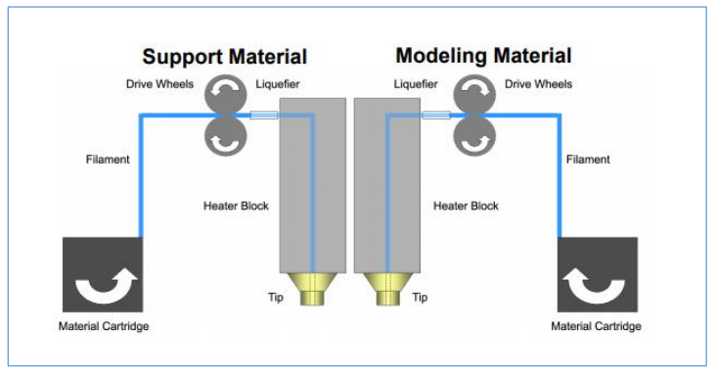

Vat Polymerization (SLA and DLP): They are most suitable for visual applications where an injection mold-like smooth surface finish and a high level of feature detail are required. SLA uses a single-point laser to cure the resin, while DLP uses a digital light projector to flash a single image of each layer all at once. Liquid photopolymer in a vat is selectively cured by Ultra-violet light.

After printing, the part needs to be cleaned from the resin and exposed to an ultraviolet source to improve its strength. Next, the support structures are removed and post-processing is carried out. SLS pars have a very good, almost isotropic mechanical properties, so they are ideal for functional parts and prototypes.

Designs with complex geometries can be easily manufactured. SLS is also excellent for medium batch production. SLS parts have a naturally grainy surface and some internal porosity. The small holes are susceptible to thermal warping and over-sintering.

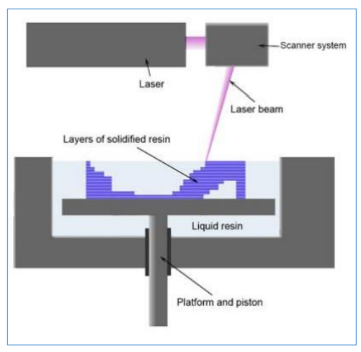

3. Powder Bed Fusion (SLS, DMLS and SLM): DMLS and SLM are suitable for producing metal parts. SLM achieves a full melt of the powder particles, while DMLS heats the metal particles to a point that they fuse together on a molecular level.

A high-energy source selectively fuses powder particles. Support structures are always required to minimize the distortion caused by the high temperatures required to fuse the metal particles. After printing the metal supports need to be removed either manually or through CNC machining. Machining may also be employed to improve the accuracy of critical features.

Finally, the parts are thermally treated to eliminate any residual stresses. The parts can be optimized to maximize their performance while minimizing their weight. Many metal alloys that are difficult to process with other technologies, such as metal super alloys, are available in DMLS/ SLM. Obviously, the cost of DMLS/ SLM 3D printing are very high. Also, the build size is limited, as precise manufacturing conditions are difficult to maintain for bigger build volumes.

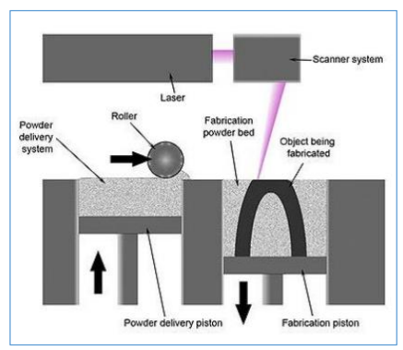

4. Material Jetting (MJ): Droplets of material are selectively deposited or cured. Material jetting works in a similar way to standard inkjet printing. However, instead of printing a single layer, multiple layers of material are deposited upon each other to create a solid part.

Multiple print heads jet hundreds of tiny droplets of photopolymer onto the build platform, which are then solidified (cured) by the ultraviolet light source. After a layer is complete, the build platform moves down one layer and the process repeats.

Support structures are always required in Material Jetting. A water-soluble material is used a s support that can be easily dissolved during post-processing and that is printed at the same time as the structural material.

Material jetting is the most precise 3D printing technology. It offers multi-material and full-colour printing capabilities. Material jetted parts have a very smooth finish and very high dimensional accuracy. Material jetting is one of the most expensive 3D printing processes. Moreover, the printed parts are brittle and photosensitive.

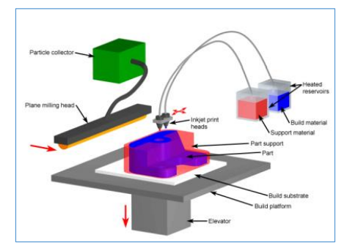

Sheet Lamination (LOM, UAM): Sheets of material are bonded and formed layer-by-layer.

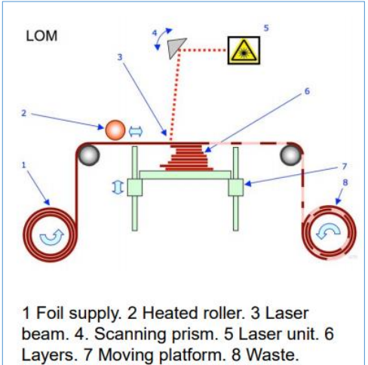

Applications 3D Printing encompasses may forms of technologies and materials as 3D printing is being used in almost all industries. A few examples are: 1. Construction: 10 one-story houses can be printed in a day. 2. Medicine: Hearing aids, Organs, Body parts, Tissues, Blood vessels, Teeth, Prosthetics, Bionics, Braces, eyewear 3. Manufacturing: Automobile parts, Cars 4. Domestic Usage: Jewelry, Toys, cutlery, Furniture 5. Clothing: Dresses, Shoes 6. Archaeology: Reconstructing fossils, bones, body parts and ancient artifacts 7. Academia: Molecular Models, Gears, Robots.

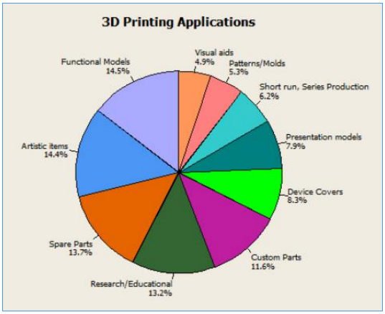

Tools and Technology used for 3D Printing Different Software packages can aid in each different stage of the design process; from CAD design, to STL repair and preparation. Some of the best software for CAD modeling include:

1. Solidworks

2. Rhinoceros

3. Fusion 360

4. Onshape

5. TinkerCAD STL repair softwares include:

1. Netfabb

2. Meshmixer Some of the popular slicing softwares are:

1. Cura

2. Simplify3D

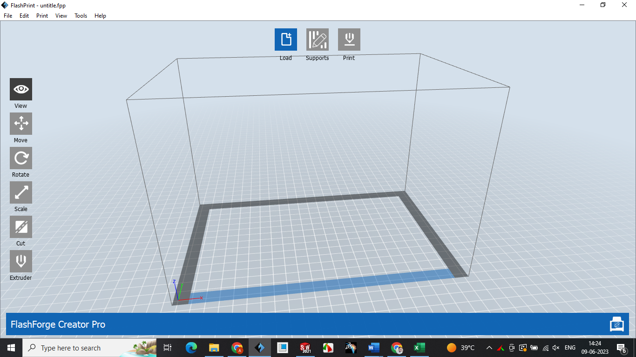

Design Parameters

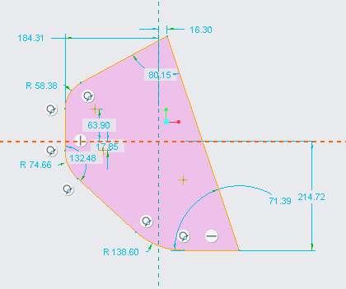

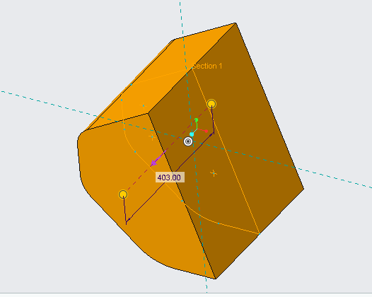

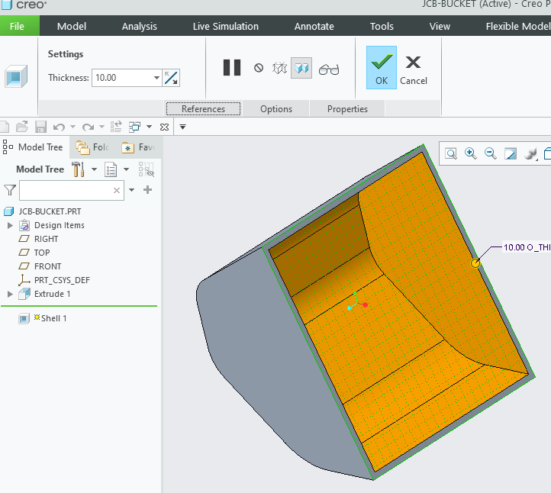

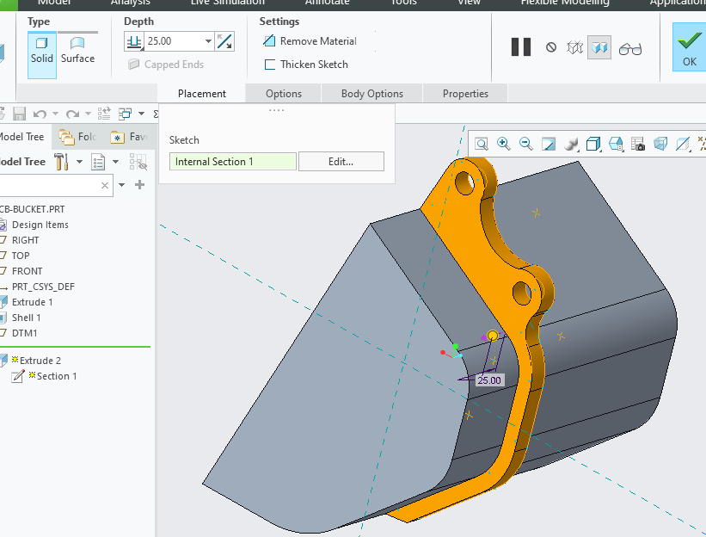

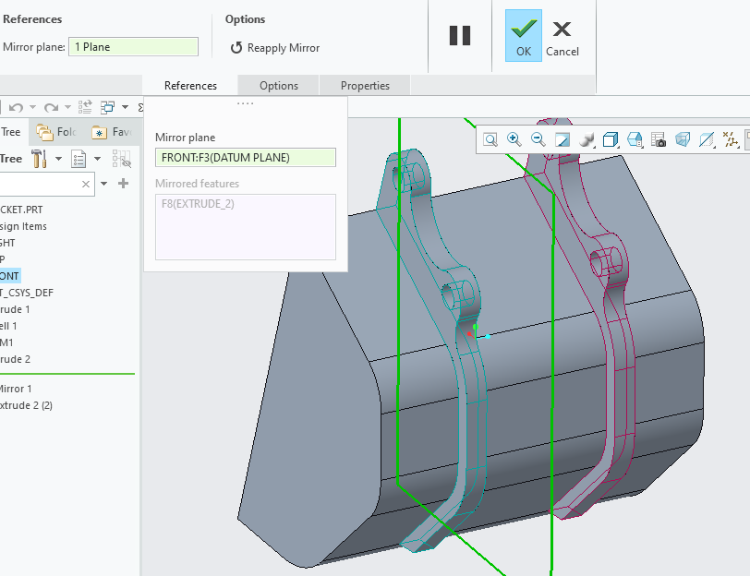

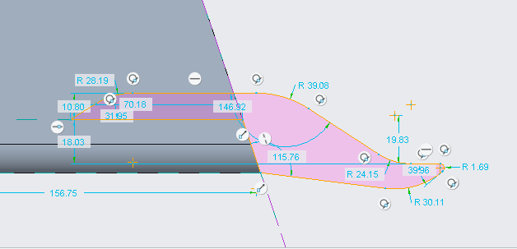

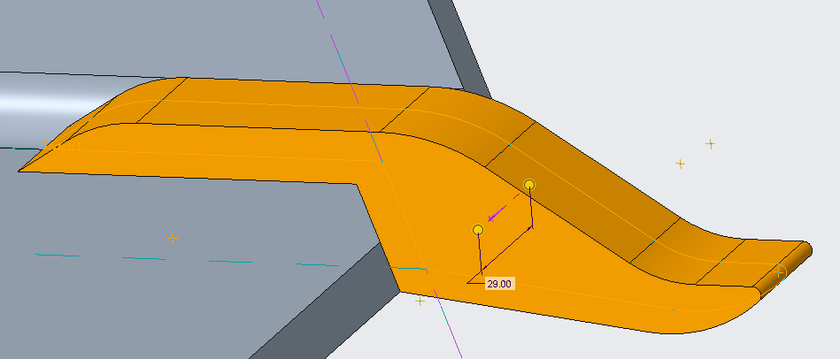 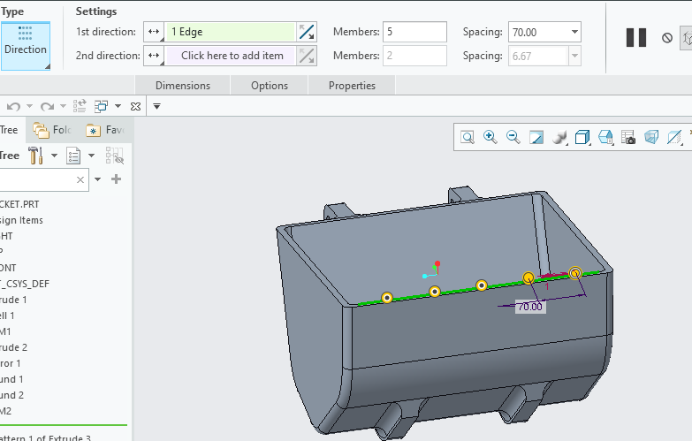

3D Printing Process

